Docker Lab Exercise

🧰 Prerequisites
- Linux system (Ubuntu 22.04/24.04 recommended)
- Docker installed and running

STEP 1: Verify Docker Setup
🧩 Commands
docker version
docker --version
docker info
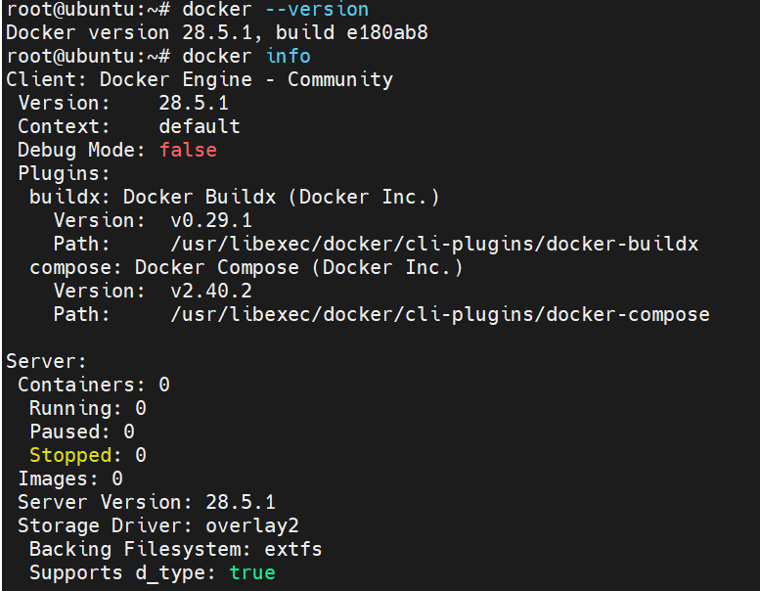
📘 Explanation
- docker version → Shows client and server versions.
- docker info → Gives system-wide info like storage driver, cgroup driver, number of containers, and images.
✅ Checkpoint
Ensure both Client and Server (Engine) versions are visible. If Cannot connect to the Docker daemon → run:
sudo systemctl start docker

STEP 2: Explore and Pull Images
🧩 Commands
docker search ubuntu
docker search nginx
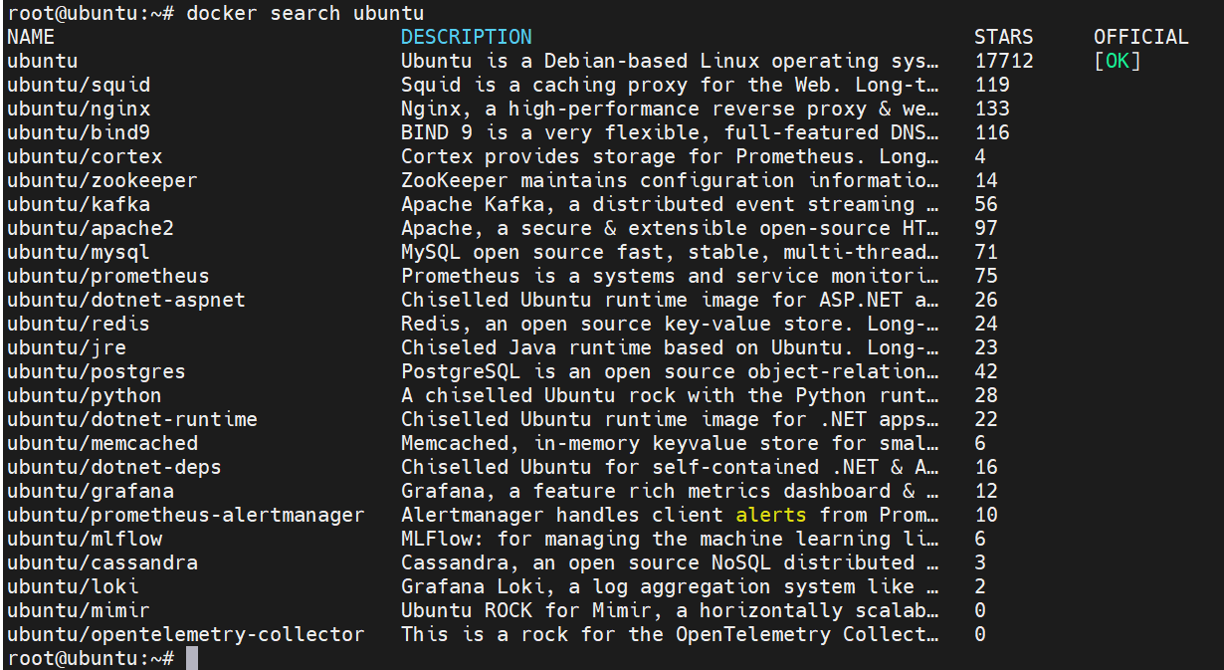
📘 Explanation
Searches Docker Hub for available images.
🧩 Pull Images
docker pull ubuntu:20.04
docker pull ubuntu:22.04
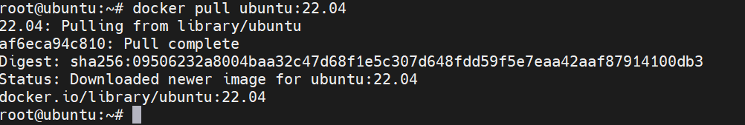
docker pull centos:8
docker pull nginx
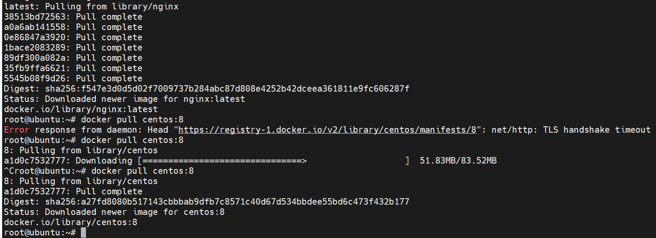
✅ Checkpoint

docker images
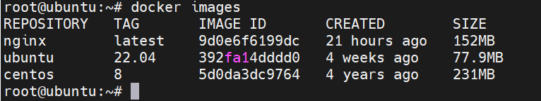
Should list all pulled images.
🔍 Verify Image Layers
docker history nginx
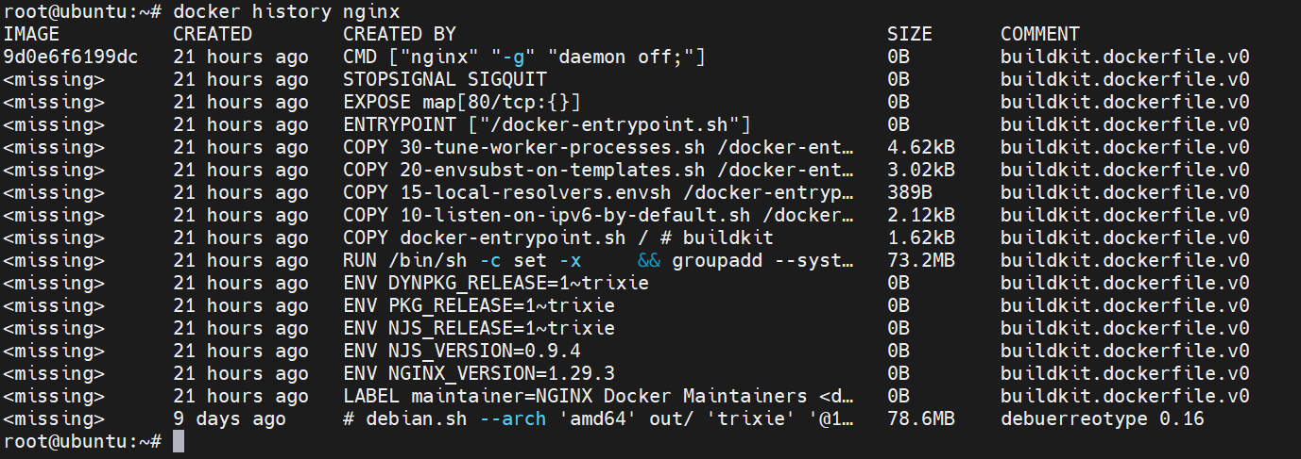

STEP 3: Running Containers (Interactive vs Detached)
🧩 Run Interactively
docker run -it --name mynginx nginx
- -it → interactive + TTY
- --name → assign a readable name
- nginx → base image
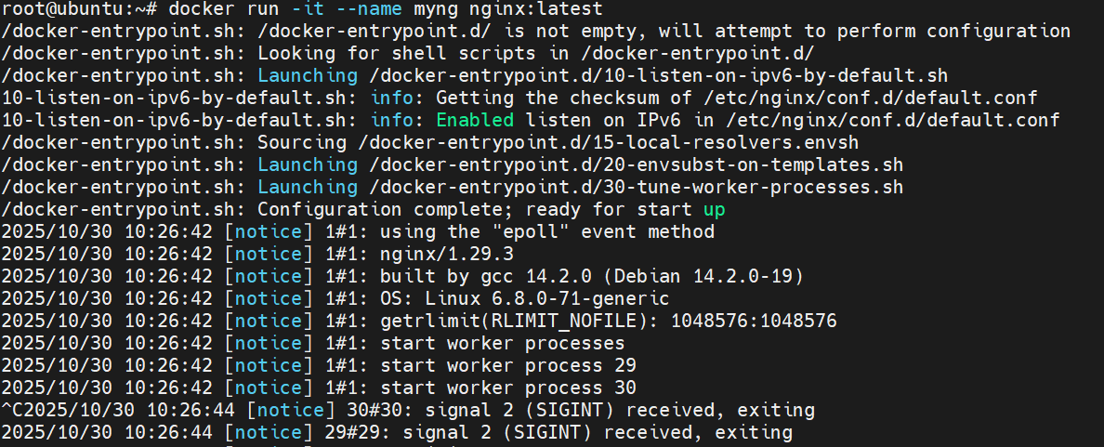

Inside container:
hostname
exit
🔹 Note: Exiting interactive mode stops the container.
🧩 Run in Detached Mode
docker run -it -d --name httpd-container httpd
Check status:
docker ps
✅ Checkpoint
You should see your container running in background with a random port mapping.

STEP 4: Container Management
🧩 List Containers
docker ps
docker ps -a
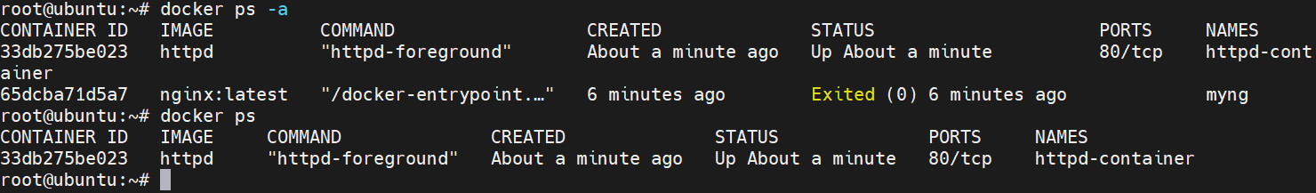
🧩 Access Running Container
docker exec -it httpd-container /bin/bash
date
exit
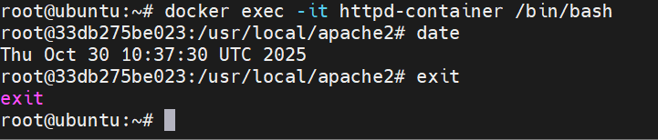
🧩 Stop/Start/Restart Containers
docker stop httpd-container
docker start httpd-container
docker restart httpd-container
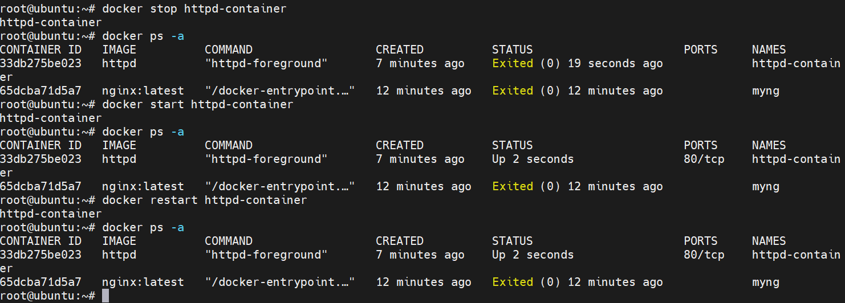
🧩 Kill a Container (Force Stop)
docker kill httpd-container
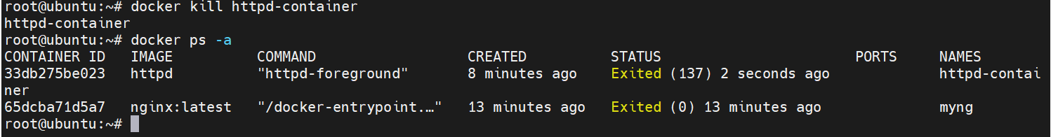

STEP 5: Container Removal & Cleanup
🧩 Remove Stopped Containers
docker rm httpd-container
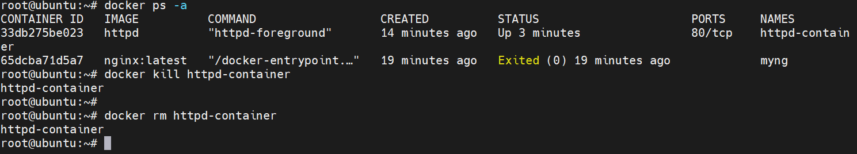
🧩 Remove Running Container (Force)
docker rm -f mynginx
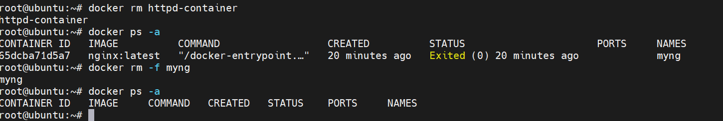
🧩 Remove Images
docker rmi ubuntu:20.04
docker rmi 54c9d81cbb44
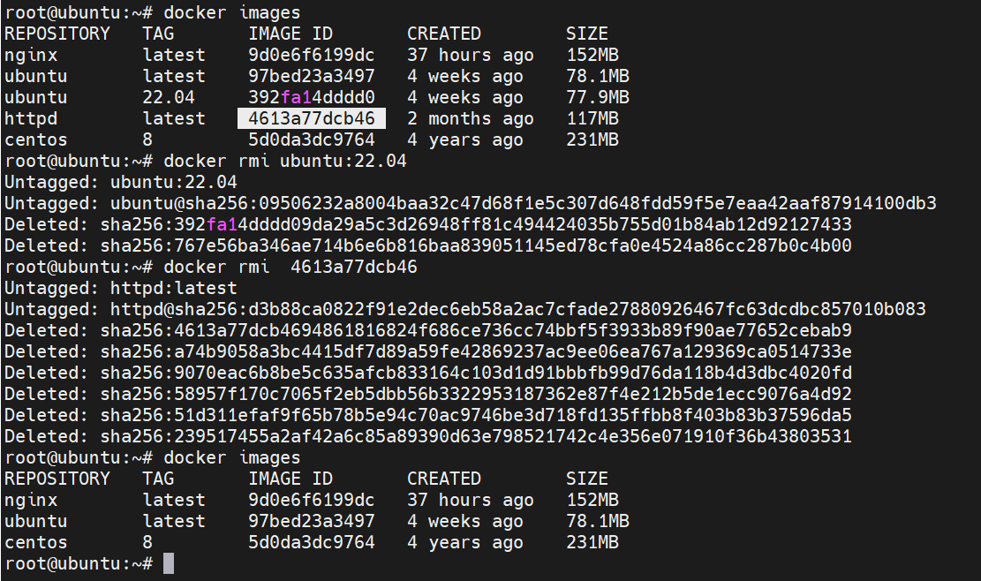
✅ Checkpoint
docker images
docker ps -a
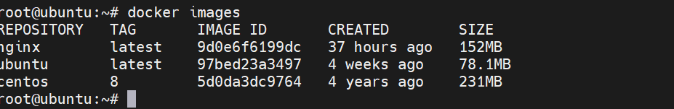
Ensure only desired containers/images remain.

STEP 6: Port Publishing (Host ↔ Container)
🧩 Run Web Servers with Port Mapping
docker run -it -d --name httpd-web-container -p 9000:80 httpd
docker run -it -d --name nginx-web-container -p 8800:80 nginx:latest
📘 Explanation
- -p 9000:80 → Maps host port 9000 to container port 80
- Useful for accessing containers via browser.
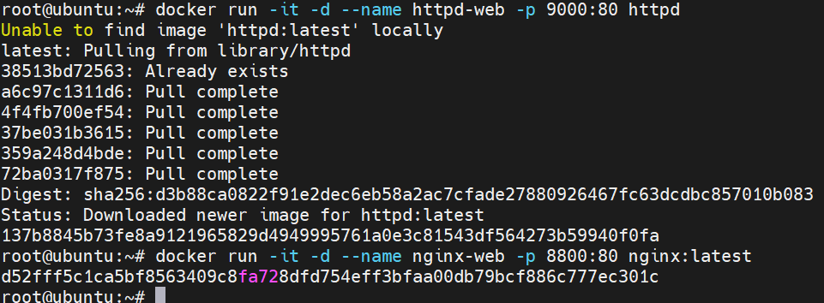
✅ Verification
docker ps
Output example:
CONTAINER ID IMAGE PORTS NAMES
b4d12a3cdce5 httpd 0.0.0.0:9000->80/tcp httpd-web-container
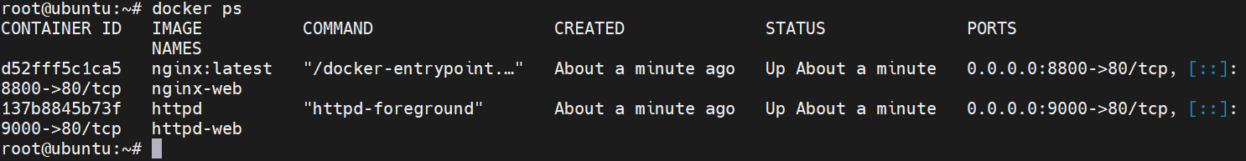
Open in browser:
- http://localhost:9000
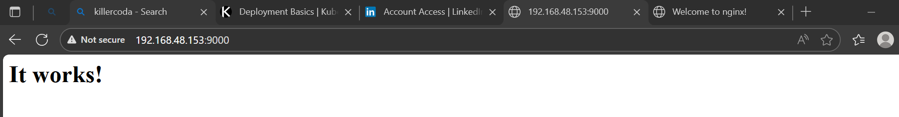
- http://localhost:8800
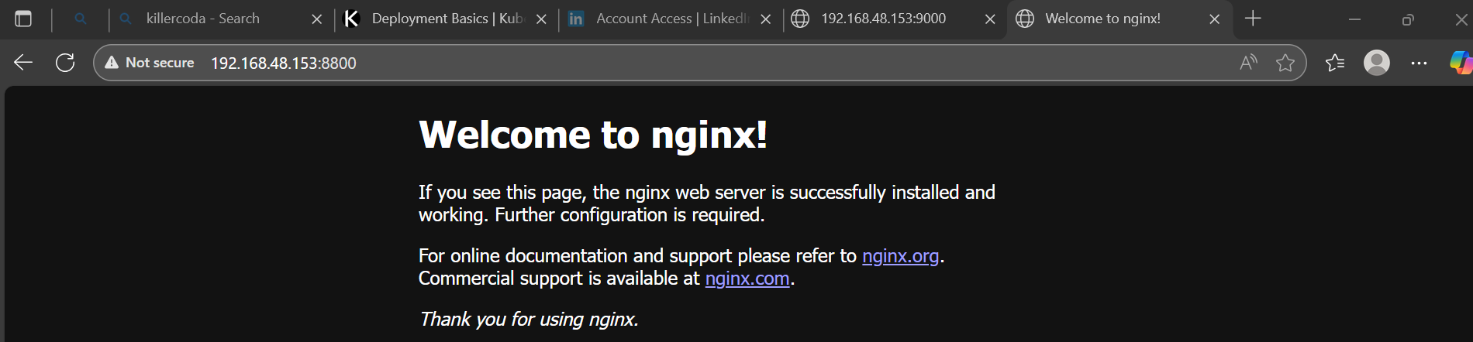

STEP 7: Container Logs
🧩 View Logs
docker logs nginx-web-container
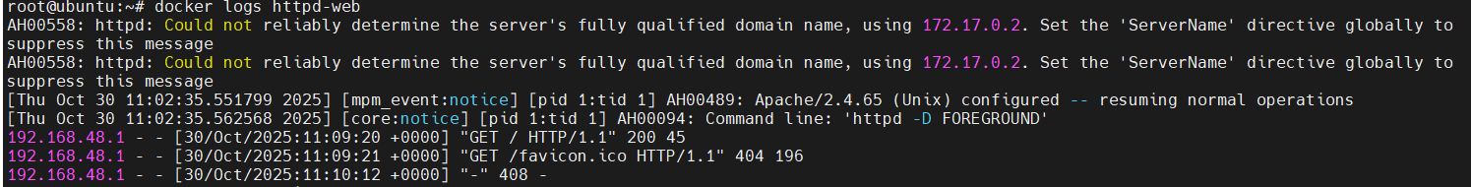
docker logs httpd-web-container
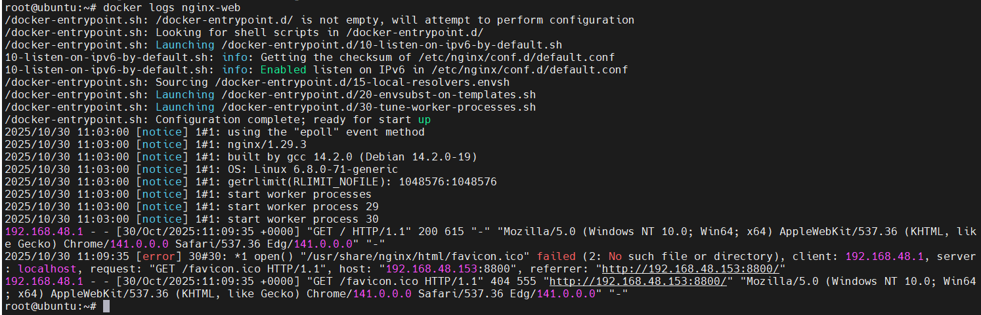
🧩 Follow Logs in Real Time
docker logs -f nginx-web-container
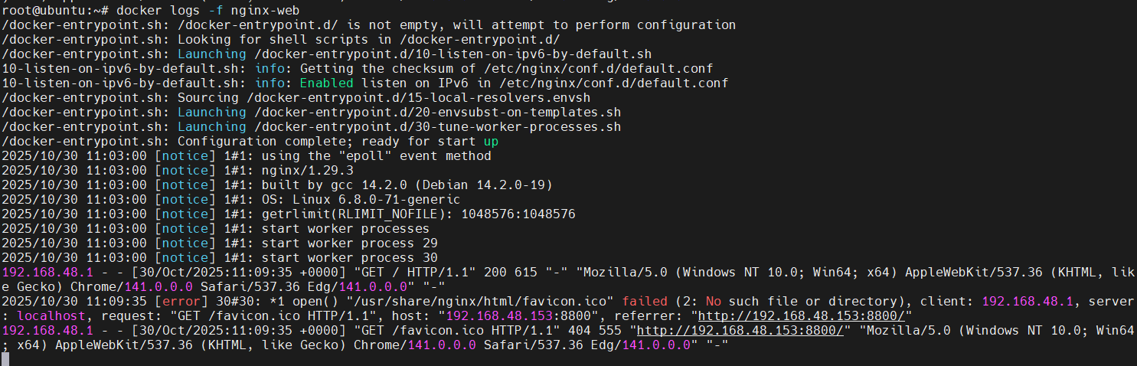
🧩 View Last 10 Lines
docker logs --tail 10 nginx-web-container
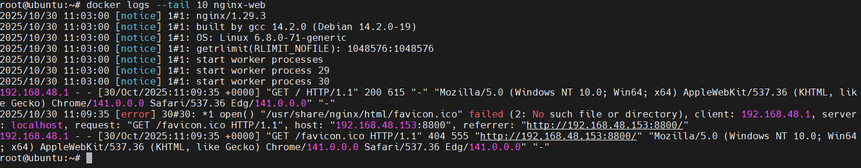
✅ Open the web page again and see logs update live.

STEP 8: Copy Files Between Host and Container
🧩 Prepare a File
echo "<h1>Hello from Docker</h1>" > index.html
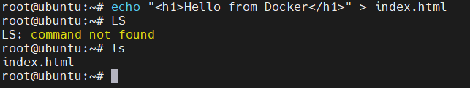
🧩 Copy to Container
docker cp index.html nginx-web-container:/usr/share/nginx/html/
docker cp index.html httpd-web-container:/usr/local/apache2/htdocs/
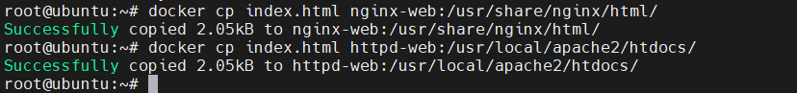
🧩 Verify Inside Container
docker exec -it nginx-web-container bash
ls /usr/share/nginx/html/
exit
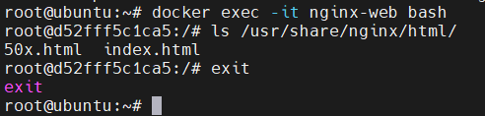
🧩 Copy Back to Host
docker cp nginx-web-container:/usr/share/nginx/html/index.html /opt/
✅ Check /opt/index.html exists on your host.
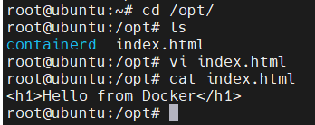

STEP 9: Commit Container Changes
🧩 Modify Running Container
docker exec -it nginx-web-container bash
echo "<h1>Custom Page</h1>" > /usr/share/nginx/html/custom.html
exit
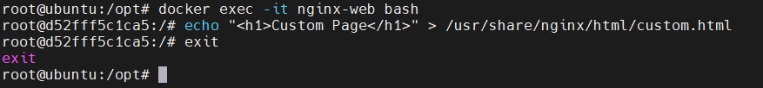
🧩 Commit Changes as New Image
docker commit nginx-web-container nginx-custom:v1
🧩 Tag Image
docker tag nginx-custom:v1 myrepo/nginx:v1
docker images
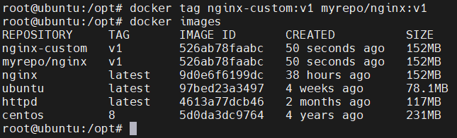
✅ New image should appear in the list.

STEP 10: Save and Load Image
🧩 Save to TAR File
docker save nginx-custom:v1 -o mynginx.tar
ls -lh mynginx.tar
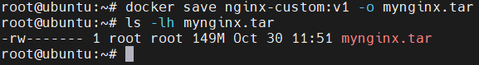

🧩 Remove Image and Reload
docker rmi nginx-custom:v1
docker load -i mynginx.tar
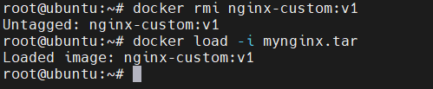
✅ Check again:
docker images
Your image should reappear.
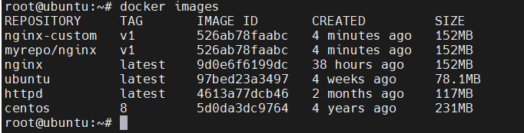

STEP 11: Cleanup
When done:
docker stop $(docker ps -q)
docker rm $(docker ps -a -q)
docker rmi $(docker images -q)
